**LAB NO 3**

**SUBMITTED BY:**

**RABEEA FATIMA  
REGISTRATION NO: 2023-BSE-049**

**SECTION: B  
SUBJECT: CLOUD COMPUTING**

# LAB# 03

**TASK 0:**

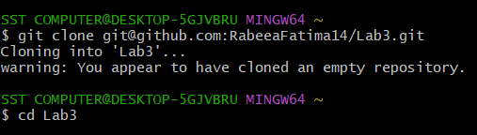

**TASK 01:**

**Handling Local and Remote Commit Conflicts.**

Step 1: Remote Change

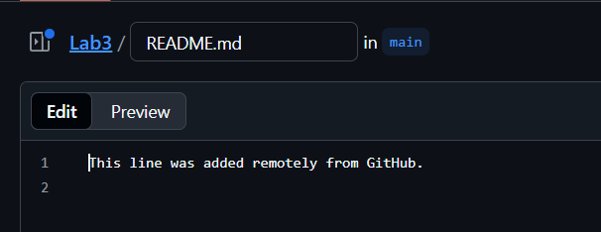

Step 2: Local Change



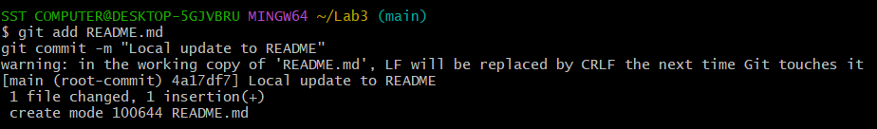

Step 3: Try to Push

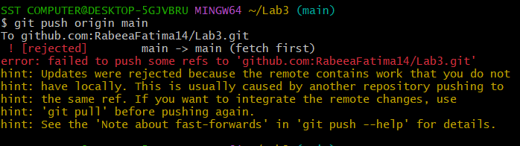

Step 4: Fix with Pull (Merge Way)

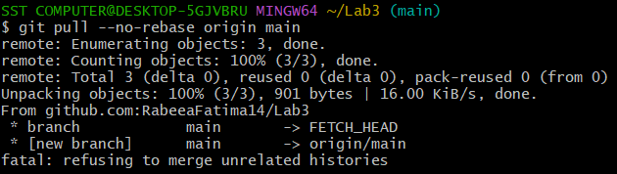

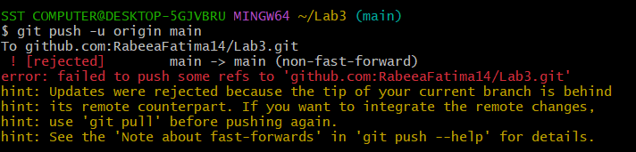

Step 5: Do It Again, but with Rebase

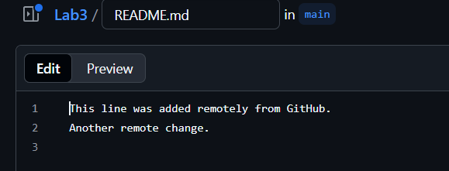

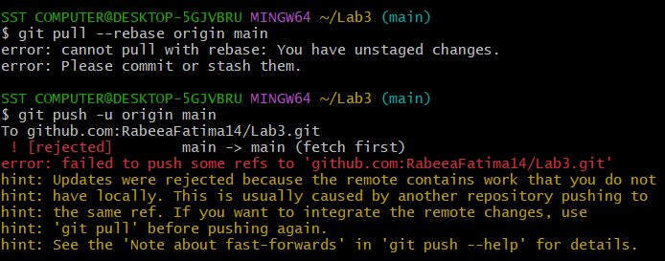

**TASK 02:**

**Creating & Resolving Merge Conflicts.**

Step 1: Remote Edit

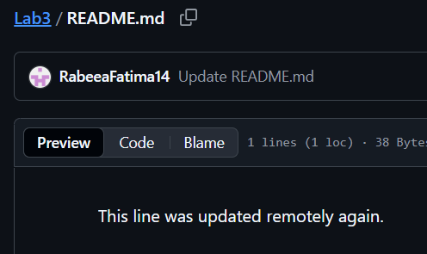

Step 2: Local Edit

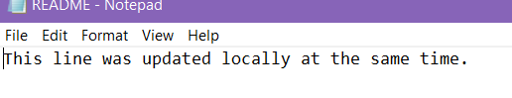

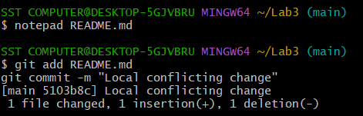

Step 3: Try to Push

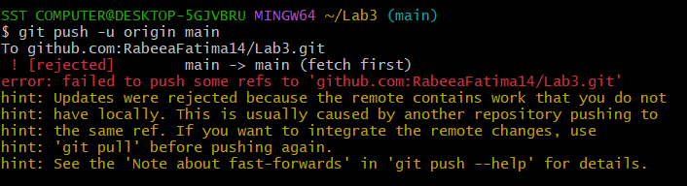

Step 4: Pull with Rebase

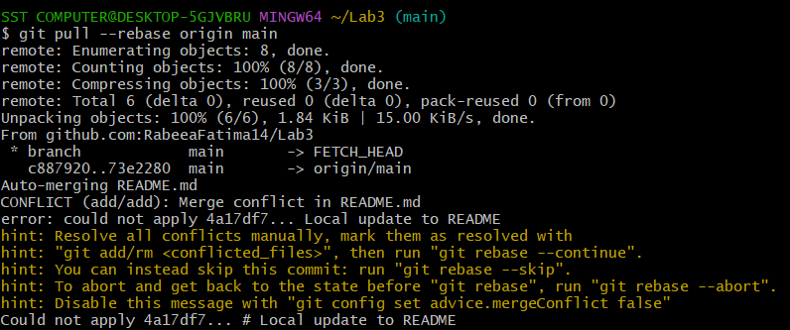

Step 5: Resolve Conflict

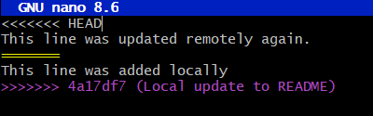

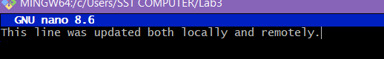

Step 6: Continue Rebase

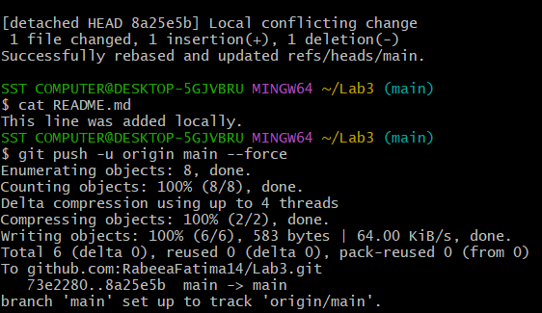

**TASK 03:**

**Managing Ignored Files.**

Step 1: Create a Folder and Files

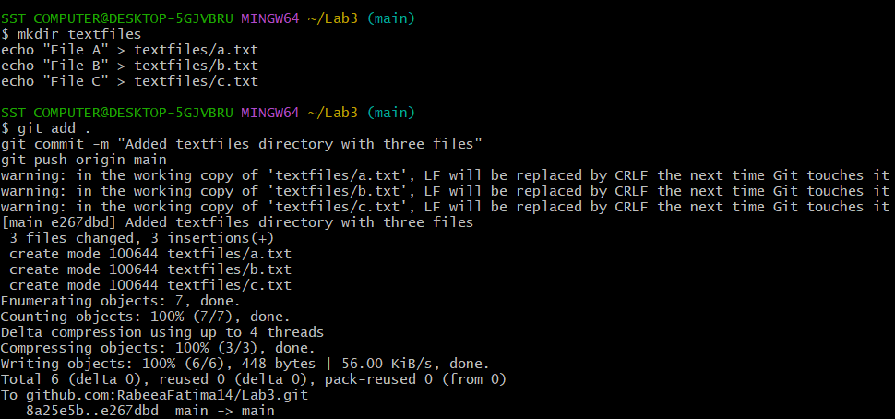

Step 2: Create .gitignore

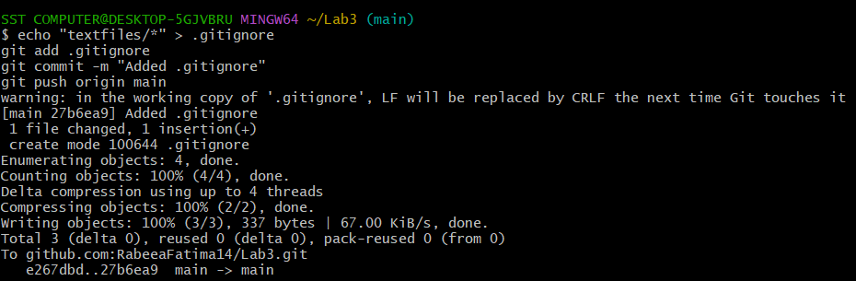

Step 3: Check on GitHub

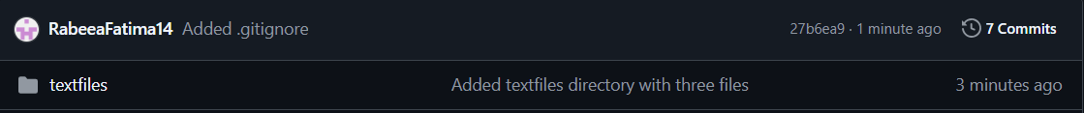

Step 4: Untrack the Folder

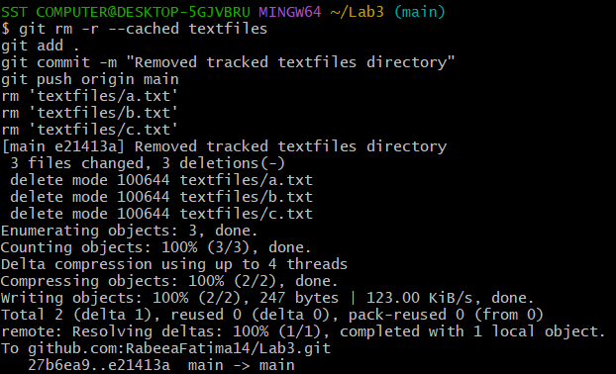

**TASK 04:**

**Create temporary changes and use Git stash.**

Step 1: Make a Branch

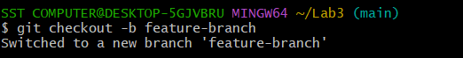

Step 2: Edit README.md, Commit

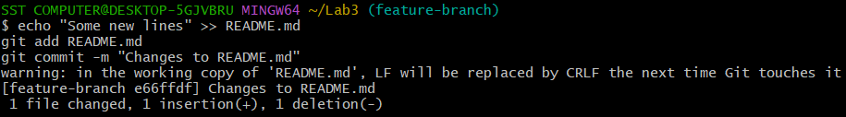

Step 3: Make Another Change (but don’t commit)

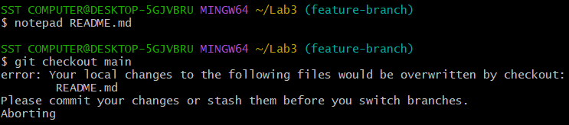

Step 4: Stash It



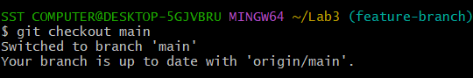

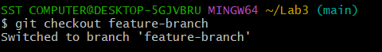

Step 5: Restore Stashed Changes

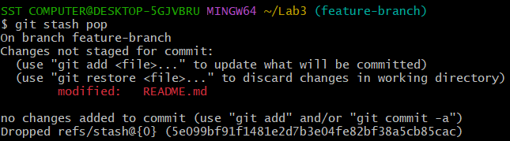

**TASK 05:**

**Check out a specific commit using Git log.**

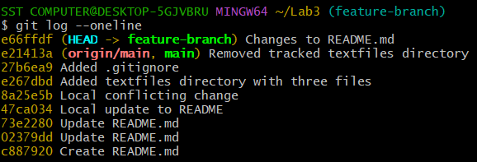

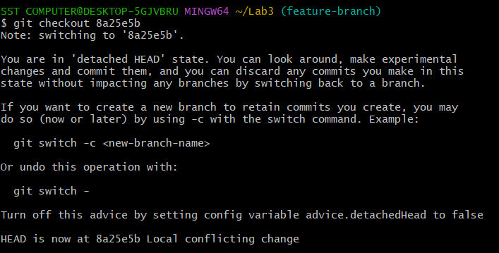

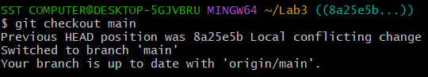

**TASK 06:**

**Resetting commits (Soft vs Hard).**

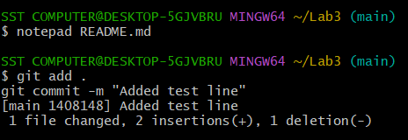

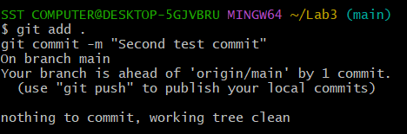

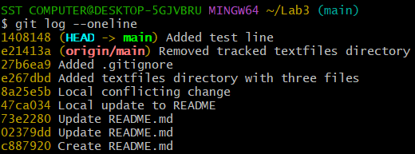

Step 1: Soft Reset

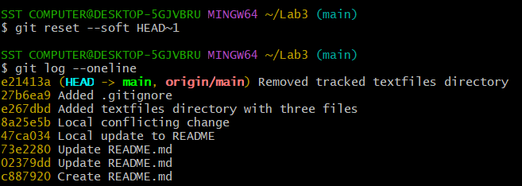

Step 2: Hard Reset

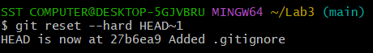

**TASK 07:**

**Amending the Last Commit.**

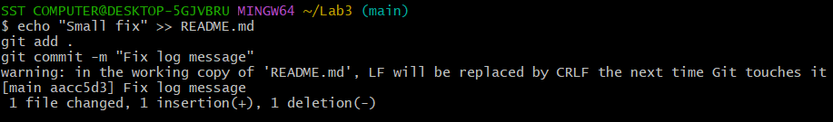

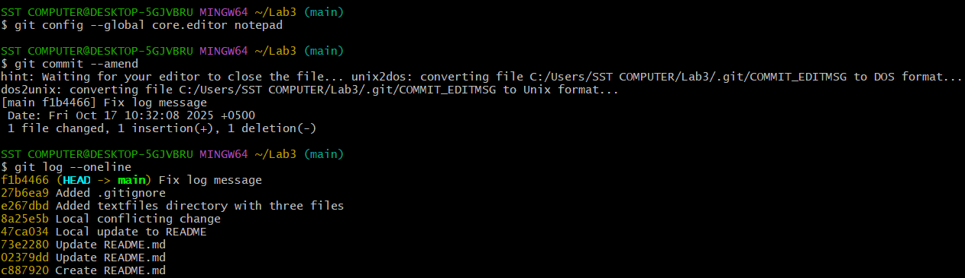

**TASK 08:**

**Reverting a Commit.**

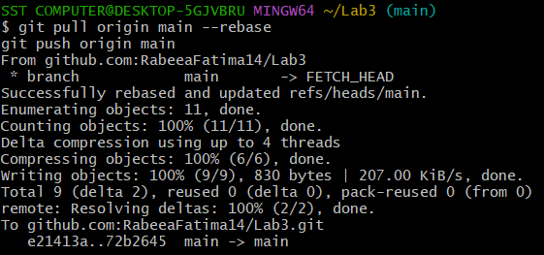

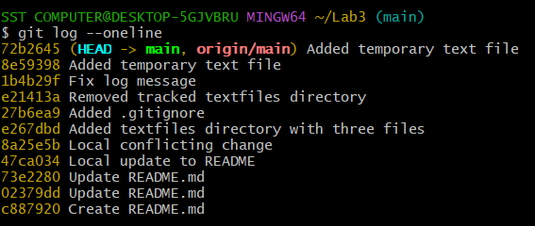

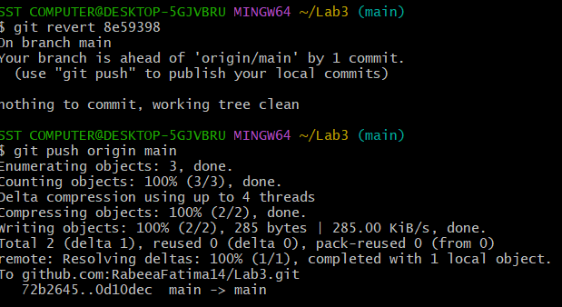

**TASK 09:**

**Force Push.**

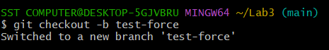

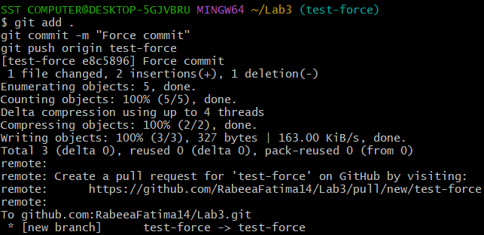

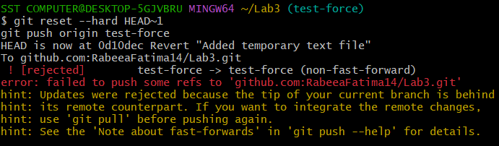

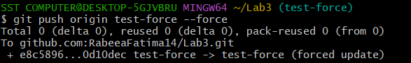

**TASK 10:**

**Running Gitea in GitHub Codespace.**

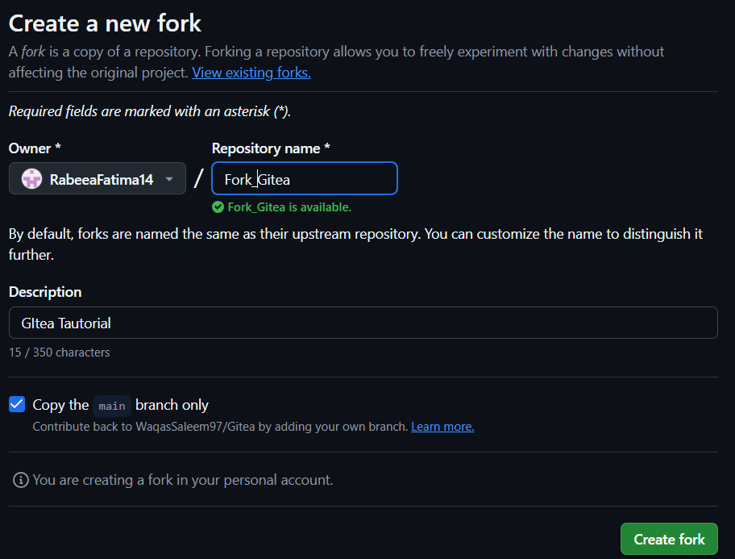

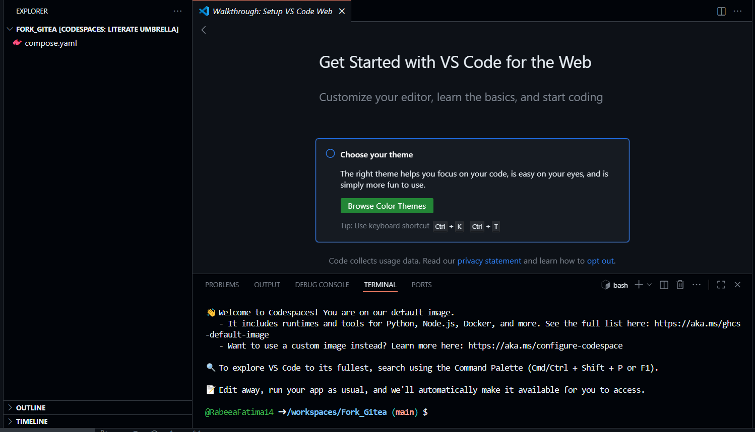

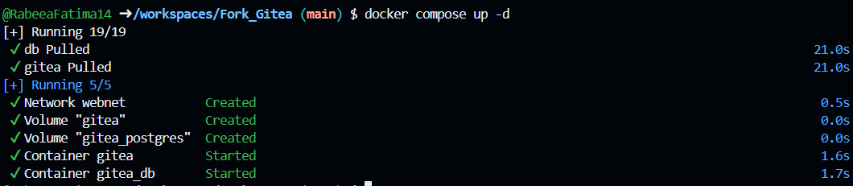

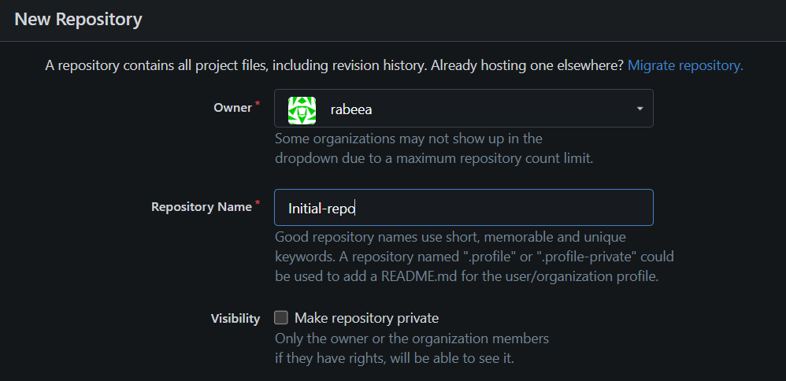

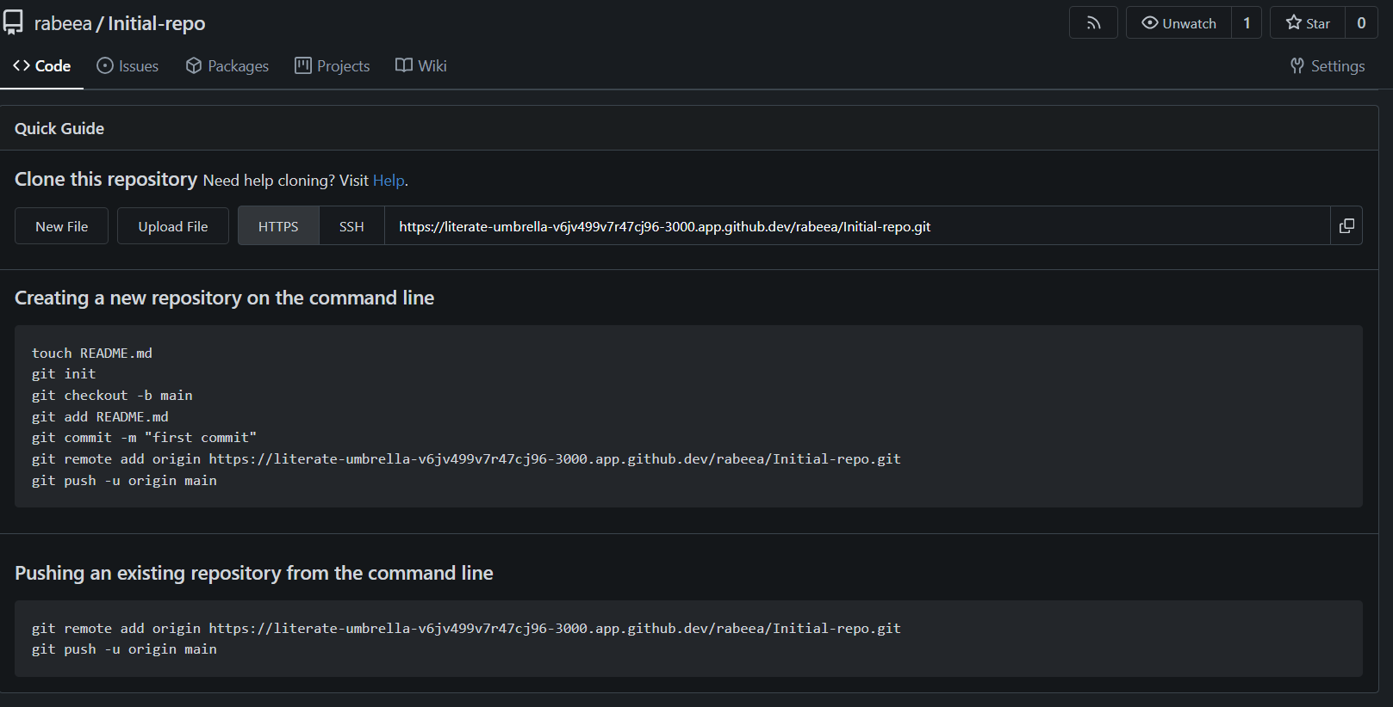

**TASK 11:**

**Creating GitHub pages portfolio site.**

Step 1: Create a GitHub repository.

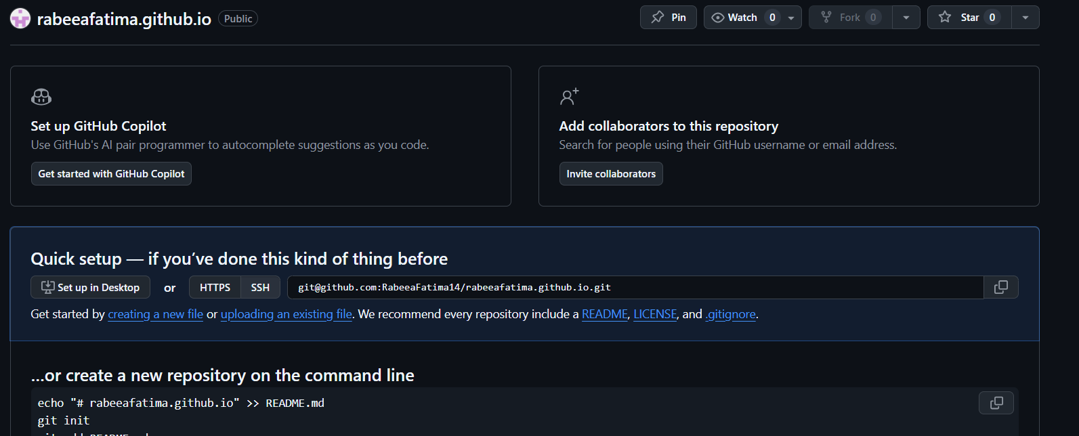

Step 2: Add static website code.

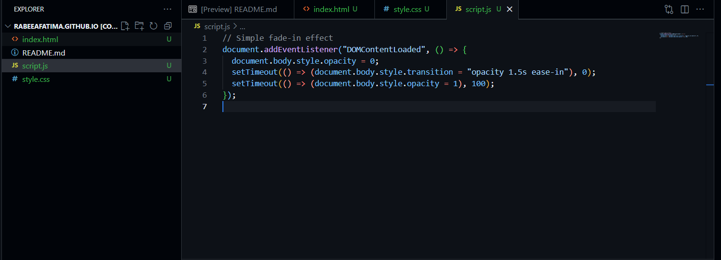

Step 3: Add static website code.

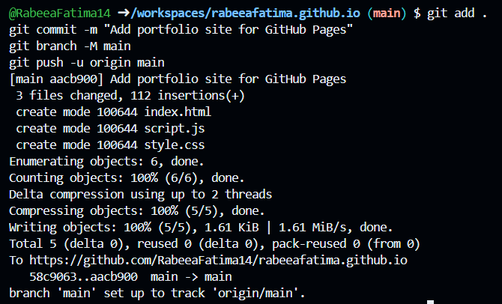

Step 4: Check GitHub pages settings.

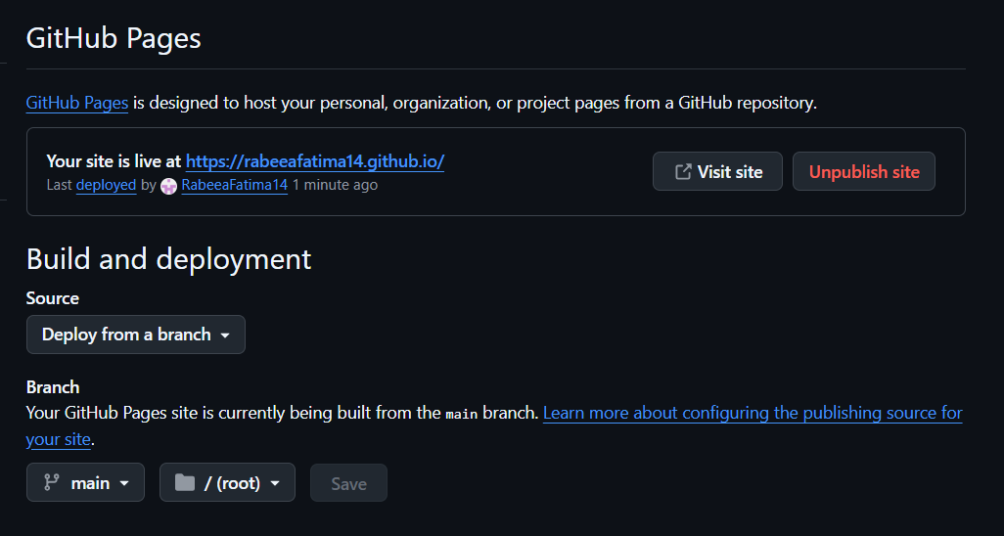

Step 5: Link to the website.

<https://rabeeafatima14.github.io/>